Cross Platform Design Doc for CA 1
Zach Ahearn K00282339
Part 1 - Cross Platform Considerations

Introduction
I developed this project using the Unity game engine and programmed it in C#. The purpose was to create a 2D cross-platform, side-scroller, space-shooter game that can run on android devices, WebGL, and desktop systems. To achieve this, the project was designed in a way where different gameplay systems such as player control, enemy spawning, power-ups, and UI management were separated into individual scripts. Unity’s component-based design allows for functionality to be attached to GameObjects as scripts, making it easier to reuse code across multiple different platforms. Input handling, physics, and rendering systems provided by Unity ensured that the game could run across platforms without major code changes.
In my project, I used prefabs extensively to allow for reusing enemy types, power-ups, and projectiles, which improves scalability and maintainability.

System Architecture
The system architecture for my project follows Unity’s component-based model. Each major gameplay system is implemented as its own script attached to specific GameObjects.
Some of my main gameplay systems are:
- PlayerController - Handles movement, shooting, and power-up logic
- EnemySpawner - Spawns enemies based on the current level
- Enemy scripts - Control each different enemy’s behaviour
- PowerUpSpawner - Spawns power ups in a timed interval
- PowerUp scripts - Manage power-up activation
- GameManager - Controls score, kill count, and resetting game
- AudioSource component - Handle playing sound effects
These systems communicate using Unity’s event-driven methods such as collision detection as well as methods that are called between scripts.

Class Diagram
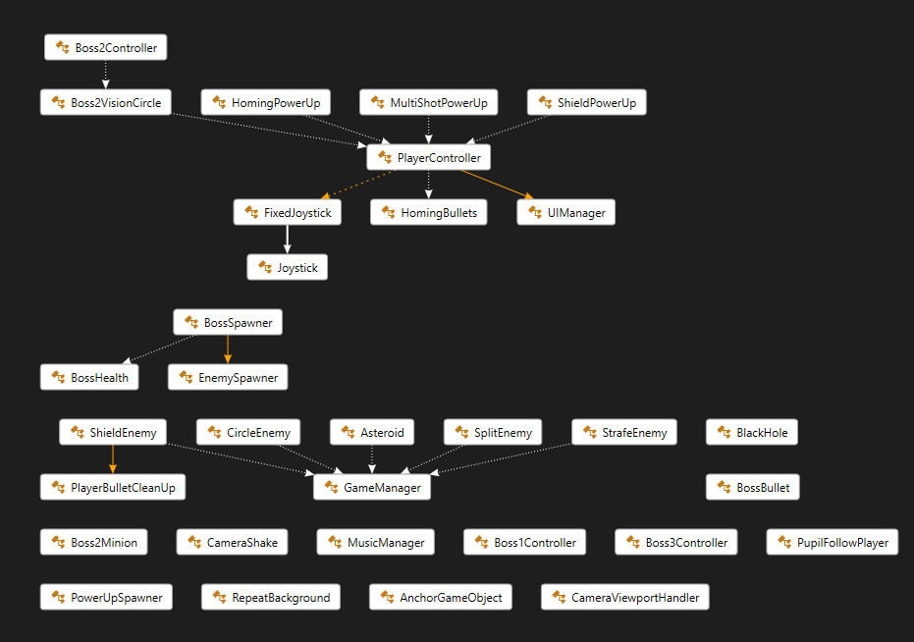
Figure 1: Class Diagram
Figure 1 shows a class diagram made for the relationships between all of my game’s scripts. Its clear that two of the scripts that are called upon the most by other scripts are the PlayerController and the GameManager.
All of the power up scripts call to the PlayerController as the PlayerContorller holds the logic for each power up. When a power up is collected, their script calls to a corresponding method in the PlayerController.
Every enemy script is connected to the GameManager script as whenever an enemy dies, they call a method in the Game Manager instance to add a kill to the kill counter, which is held only in the Game Manager.
This design follows object-oriented principles such as composition and aggregation.

Sequence Diagram
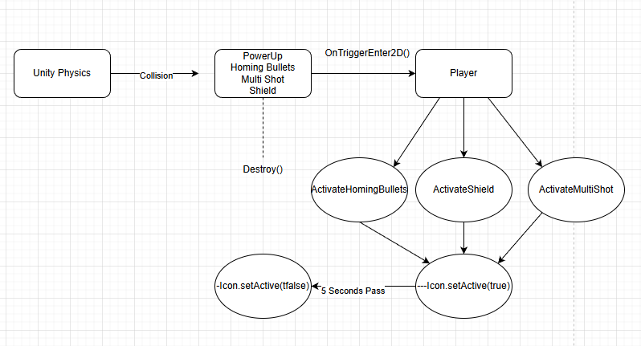
Figure 2: Sequence Diagram for Power Ups
Figure 2 shows a sequence diagram for when the player collects a power up. Unity’s physics are applied to the 3 power ups. When any of the power ups enter the player’s collider using the OnTriggerEnter2D, the respective power up object is destroyed. Then, depending on which power up was gotten, a respective method inside the player controller is called to activate that power up’s logic. That power up’s icon is also activated on the UI. After 5 seconds, the power up deactivates, and the UI icons are set back to inactive.

C# coding examples relevant to project
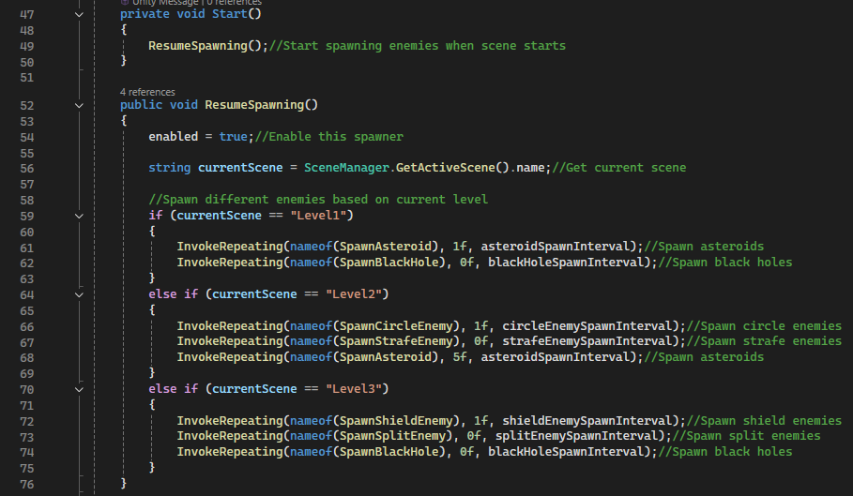
Figure 3: Spawning Enemies
Figure 3 shows part of the code used to spawn in my enemies. Enemies are spawned based on the currently loaded level. The InvokeRepeating() method is used to repeatedly call an enemy spawn function at fixed time intervals. It takes in three parameters: the method name to call, the delay before the first call, and the repeat interval. For example, line 61 called the SpawnAsteroid method, waits 1 seconds, and repeats based on whatever the spawn interval for the asteroid was set to.
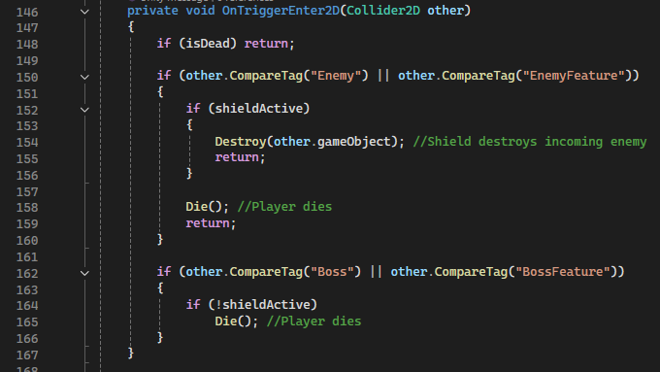
Figure 4: Player Dying/Shield Power Up Collision
Figure 4 shows how the player handles collision and dying due to that collision. There are 4 different tags, and when a game object collides with the player while having one of these tags, the Die() method is called and the player will die. These are Enemy, EnemyFeature, Boss, and BossFeature. Part of this collision logic also has to do with the shield power up the player can get. If the player has the shield power up, if they collide with an enemy or enemy feature, the enemy/feature is destroyed and “return;” is used to stop the Die() function being called. However, if the player has a shield and collides with a boss or boss feature, the Die() function isn’t called, and nothing happens. This is to stop the player from being able to destroy a boss or its features using a player shield.

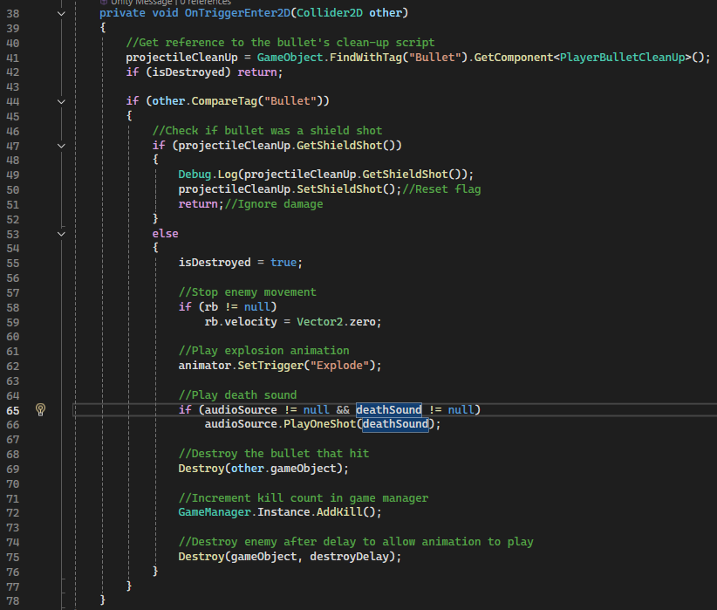
Figure 5: Shield Enemy Collision
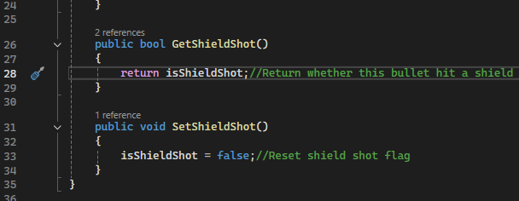
Figure 6: Checking for if shield shot
Figures 5 and 6 are how my shield enemy handles his shield getting shot. When the shield enemy is shot, they use a method inside the player bullet clean up to check if the shield was shot. If it was, damage to the enemy is ignored. This is done using a flag that is set whenever the shield is shot. When ever the shield is shot, this flag is reset, waiting for the next time the shield is shot instead of staying active so the player can kill the enemy if they shoot the enemy themself.

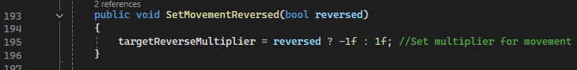
Figure 7: Setting Reversed Multiplier
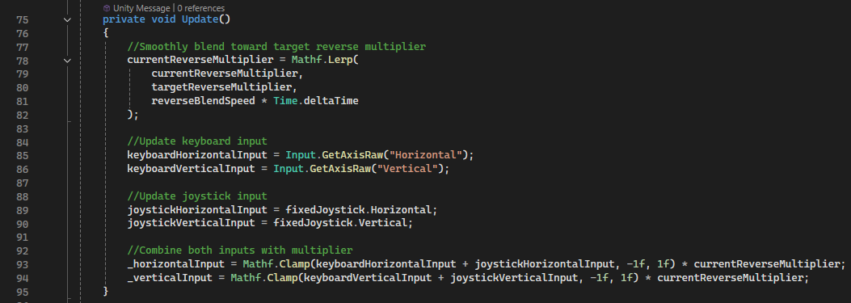
Figure 8: Applying reversed movement
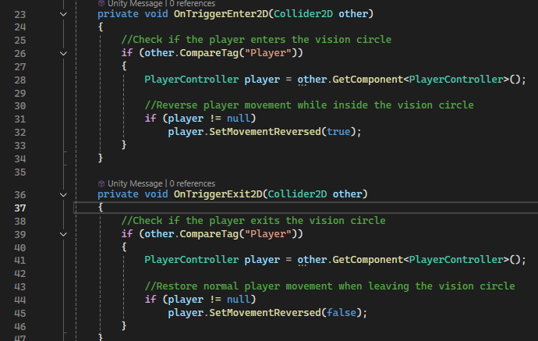
Figure 9: Calling method to reverse movement
Figures 7 to 9 represent the players movement, as well as how the player’s movement is reversed under certain conditions. The 2nd boss in the game has a vision cone that when the player is inside of, their movement is reversed. Shown in figure 9 is how this works, with the setMovementReversed() method being set to true or false, depending on if the player is colliding with the vision circle or not. The setMovementReversed() method sets the target multiplier based on whether reversed movement should be enabled or disabled. Line 78 to 81 of figure 8 uses linear interpolation to gradually move the current multiplier toward the target multiplier over time. This allows for smooth changes in movement direction. The multiplier is then applied to the player’s input. When the multiplier is 1, input behaves normally. When the multiplier becomes -1, the input values are inverted. When pressing right normally, it moves the player to the right. When pressing right while reversed, it moves the player to the left.
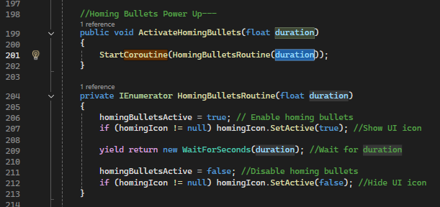
Figure 10: Use of Coroutines (Bullet Powerup eg)
Something I used extensively in my project were coroutines. I used them close to every time I needed something to have a duration or a delay. Figure 10 is an example of using a coroutine for my bullet powerup. When a pullet powerup is collected, the coroutine is started. The homing bullets are enabled and the icon to display the active powerup is enabled. After a certain amount of time, depending on what the duration variable is set to, the homing bullet powerup is set to false and the icon is disabled.
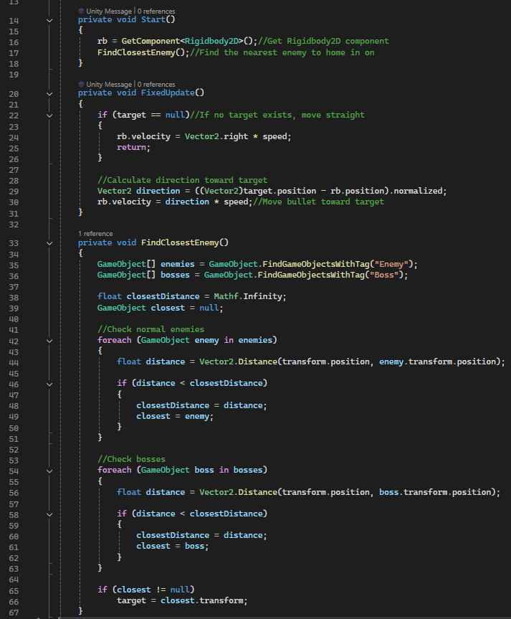
Figure 11: Homing Bullet Logic
Figure 11 then showcases the logic behind the homing bullet logic. At Start(), the function FindClosestEnemy() is called to find which enemy to track. The FindClosestEnemy() function searches for all GameObjects tagged as ‘Enemy’ and ‘Boss’, then iterates through them to calculate the distance between the bullet’s current position and each possible target. The closest object is decided by comparing distances and storing the smallest value, and its transform is assigned as the bullet’s target.

During FixedUpdate(), the bullet checks whether a target still exists. If no valid target is found, which can happen if all enemies are destroyed, the bullet continues moving straight forward using a default rightward velocity. If a target does exist, the script calculates a normalized direction vector from the bullet’s current position to the target’s position. The bullet’s velocity is then updated to move toward the target at the set speed.

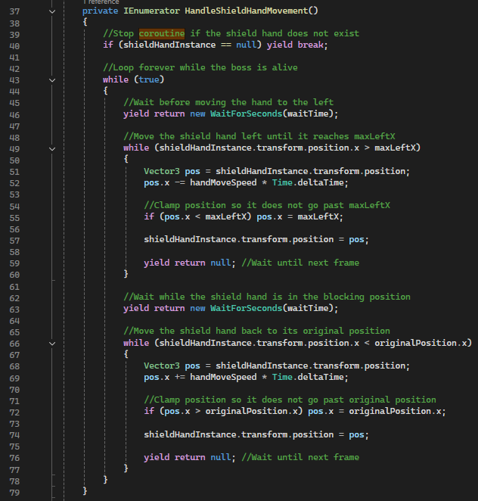
Figure 12: Final Boss Shield Logic
Another example of using a coroutine is my final boss’s shield. The is a giant hand that moves out in front of the boss to block player projectiles, essentially working as an immunity phase. This works my loops its movement for as long as the boss is alive. Every 5 seconds, the shield is moved to a maximum left x, positioning it in front of the boss. After another 5 seconds, the shield is transformed back to its original position, repeating its cycle over and over again.

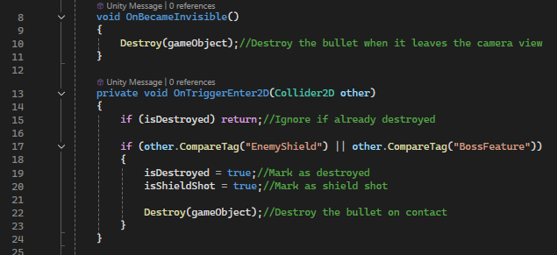
Figure 13; Bullet Cleanup
Figure 13 shows my bullet cleanup script. This is how the final boss is prevented from dying. When the bullet collides with an object tagged as ‘BossFeature’ (Final boss’s shield), the bullet is destroyed. Since the boss’s shield is a separate prefab from the boss itself, it doesn’t affect the boss’s health when shot at, stopping the player’s bullet before it reaches the boss.

Provide appropriate critical analysis and conclusions about developing this 2D game in Unity. Think about and discuss how developing in Unity is similar or different to developing in C++
I really enjoyed making this game in Unity. Unity’s UI is very clear and customisable. Making objects and scripts is quite easy and having a constant visual of how the game looks while it’s being made is a huge help. Learning how prefabs work in Unity has been very helpful in knowing how to spawn objects and remove them without taking up resources and memory. I believe Unity is a great game engine and is good for all users who want to create games.
When it comes to the similarities and differences between Unity and C++, I think they are quite different but can see the similarities they share. Unity writes scripts in C# to give logic to objects. This is the same for coding in C++. The code itself is very similar and both languages are rooted in the C language.
A big advantage of Unity is its use of components. Scripts can be attached to GameObjects, allowing behaviour to be easily reused and modified. In C++, this requires more complex class hierarchies and manual system management.
In C++, developers must manually implement rendering, input handling, physics, and memory management. Unity provides built-in systems that handle these automatically.
Unity also simplifies cross-platform development. The same project can be built for mobile, WebGL, and desktop with minimal changes. In C++, separate platform-specific implementations would usually be needed.
Being able to constantly see the game being made is a big difference in Unity compared to C++. This makes visualizing the final product for a game much easier in Unity. The biggest difference between both is that Unity can be limited in some ways. The user is limited to what Unity has to offer in its UI. In C++, if a user knows how to, then they can create anything they can think of without limit.
As a final conclusion on which one I prefer, I like Unity the most thanks to how easy it is to use and having an interface to work from stands out to me more.

Creating the game for Itch.io
Since this game was cross platform, it was made to be on both mobile and desktop. To publish the game for desktop, I uploaded it to itch.io. To do this, I had to build the game as a WebGL.
- Firstly, I went into my project’s build settings and switched the platform to WebGL.
- I then set the default canvas size to 1920 by 1080.
- I set the color space to gamma.
- Then I made a build of the game, which comes in the form of a zip file
- Then I signed into my Itch.io account and navigated to the dashboard.
- From there, I can create a new project.
- I gave it a title and set the ‘kind of project’ to HTML.
- I then uploaded the zip folder and enabled ‘This file will be played in the browser’
- I set the embed options to ‘embed in page’ and manually set the size to 1920 by 1080.
- Finally, I set the visibility to public so any user can access and play the game.
Part 2 – Game Design

Provide an overview of the game use appropriate screen shot
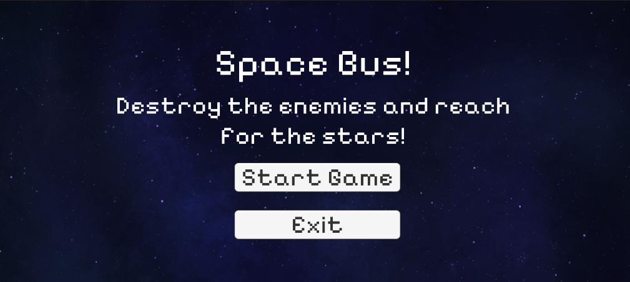
Figure 14: Main Menu
- What is the game?
My game is a 2D space shooter side scroller where the player controls a bus with rockets and must survive waves of enemies while collecting power-ups. The game takes place in outer space, where the player is attacked by many different enemies.
- What do I control?
The player controls a single rocket-powered bus using keyboard or touch input.
- What is the main focus?
The main focus of my game to avoid threats, shoot enemies, and make it to the end of each level, where the player must defeat a unique boss.
- What’s different about my game?
The biggest difference about my game are my bosses. They are all connected, all being parts of one enemy, which the player must fight and defeat on the finally level to beat the game. I also have unique power ups, allowing the players bullets to track to enemies or shoot multiple bullets at once. Each of my enemies are also unique, each having their own unique mechanic.

FEATURE SET
My game includes the following features:
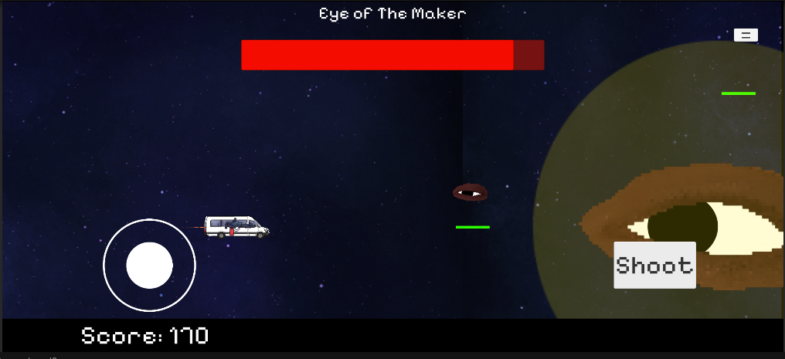
Figure 15: Boss Fight
- Player movement
- Shooting system
- Multiple Levels
- Multiple enemy types
- Multiple Bosses
- Power-ups
- Collision detection
- Sound effects
- UI displaying score, Boss Names/Health Bars
- Cross-platform support with Mobile, WebGL, and Desktop

GENERAL FEATURES
Physics
Unity’s 2D physics system was used to handle movement and collision detection. Rigidbody2D components allow objects such as the player, enemies, and projectiles to move using physics-based velocity, while Collider2D components detect interactions between objects. Trigger colliders are used to detect events such as collecting power-ups or detecting damage.
Prefabs
Prefabs were heavily used throughout the project. They allowed for the reusing of enemies, bullets, power-ups, and bosses. This improved development efficiency because changes made to a prefab automatically applied to all instances. It also simplified spawning enemies dynamically during gameplay using scripts such as the EnemySpawner.
Scripts
My game uses many C# scripts to control gameplay systems such as player movement, object clean-up, enemy behaviour, power-ups, UI updates, and game state management. These scripts communicate with each other using references and events, allowing modular and maintainable code structure.
UI
A Canvas was used to display important player information such as score, power-up indicators, and boss health bars. UI elements such as Sliders, Text, and Icons provide visual feedback to the player and improve usability.

Audio
AudioSource components were implemented to handle sound effects including shooting, enemy/boss/player death, power-up collection, and background track. The PlayOneShot() method allows sounds to play without interrupting other audio, improving sound reliability and responsiveness.
Cross-Platform
My game supports multiple platforms including mobile, WebGL, and desktop. This was achieved by using Unity’s cross-platform input handling, and platform-independent scripting. The UI and certain in-game objects like spawners used anchors to secure their positions to certain parts of the camera, ensuring their logic wasn’t affected due to changes in resolution. The same code works across all platforms with minimal modification.
Scene Management
Scene management is used to control different levels and gameplay progression. Each level contains different enemy types, each with their own behaviour, which is controlled dynamically through scripts based on the active scene.
Overall, Unity’s built-in systems allowed efficient development of a scalable, cross-platform 2D game.

MULTI-PLAYER FEATURES (if any)
My game does not include multiplayer functionality. It is designed as a single-player experience focused on survival and skill.

GAME PLAY
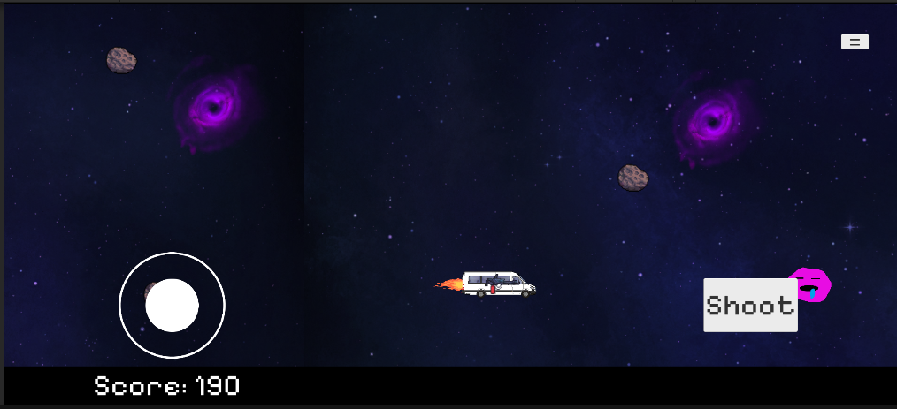
Figure 16: Gameplay
The player controls a rocket powered bus and must avoid enemies while shooting them. Enemies spawn continuously. Power-ups provide temporary advantages. The player’s objective is to eliminate enough enemies to spawn the boss of the level. There are 3 bosses, one for each level. These bosses have their own unique mechanics the player must learn to deal with and overcome. Once the player eliminates a boss, they move onto the next level. The game ends once all levels are beaten, or the player dies.

Conclusion
In conclusion, this project thought me about the development of a cross-platform 2D game using Unity and C#. Unity’s architecture made it easier to organise gameplay systems such as player control, enemy spawning, power-ups, UI, and audio into separate scripts. This improved code structure and maintainability. I learned a lot about the prefab system which allowed efficient reuse of enemies, projectiles, and power-ups. I also learned a lot about using coroutines since I had to use them through my project for many different aspects, such and powerup durations, boss and enemy shooting intervals, and my final boss’s shield logic to make it go right and left on an interval. Overall, this project helped strengthen my understanding of Unity, C#, and cross-platform game development, while producing a complete and functional 2D game.

